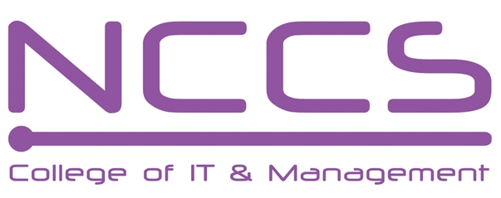
National College of Computer Studies
(NCCS-College of IT & Management)
Final Make-Up Examination (2018)
BSc. CSIT/First Semester/ CSC 111 : Digital Logic

Candidates are required to answer the questions in their own words as far as practicable.

Full Marks: 60
Pass Marks: 30
Time: 3 Hours

Long Answer Questions:
Attempt any two questions. [2×10=20]
- What is synchronous counter? Design a Mod-7 synchronous up/down counter using a TFF.
- What is magnitude comparator? Explain 4-bit magnitude comparator in details.
- Define shift register. Explain different types of shift register with necessary diagram.

Short Answer Questions:
Attempt any eight questions. [8×5=40]
- Convert (2C6B.F06) to decimal, octal and binary.
- Express F (A,B,C)=A'BC'+(A+B')(B+C+AB') into Sum of minterms and Product of Maxterms and simplify the result using K map.
- Design a full subtractor using NOR gates only.
- Design a code conversion circuit that converts 4 bit binary to 4bit gray code.
- What is Parity bit? Design a 3 bit even parity generator and corresponding parity checker circuits.
- Design a code conversion circuit for BCD to Excess-3 using ROM.
- Design the given Boolean function using PAL.
F1(A,B,C)=(1,2,4,5,7)
F2(A,B,C)=( 0,1,3,5,7)
- Describe SR flip flop along with its truth table, diagram and characteristic equations.
- Write short notes on:
    - Universal gate
    - MUX and DMUX
    - Johnson counter

**Best of Luck**

